SEIU CA DD Council
Conference
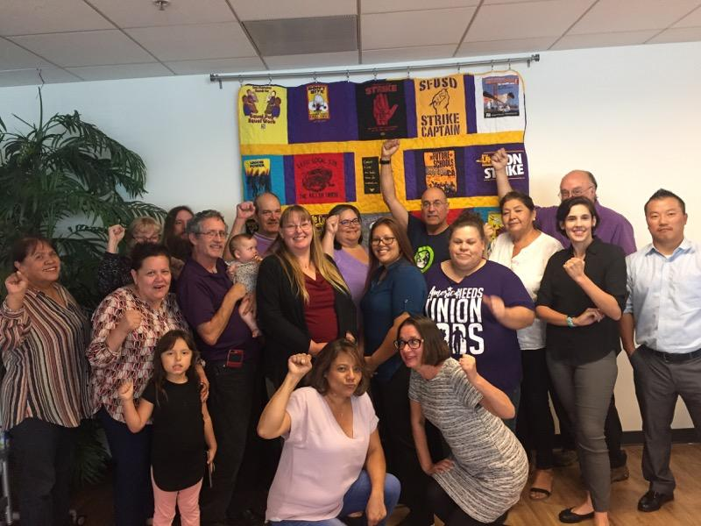
September 7th, 2019
10:00 AM to 4:00 PM SEIU Local 1021,
350 Rhode Island, Suite 100, San Francisco, CA 94103
Enter on Kansas St.

RSVP & General Information:
David Mulvey • d_mulvey@hotmail.com, 805-286-2525
Eric Stern • sternbychoice@gmail.com, 510-318-0318
Social Hour: Stay for a drink and an early bite after the Conference.
Travel and lodging must be arranged through your Local.

AGENDA
10:00 – 11:30 Chapter Reports
11:30 - 12:00 Organizing Update
12:00 – 1:00 Lunch
1:00 – 2:00 Budget & Legislation
2:00 – 2:30 Officer Election for
New Co-Chair
2:30– 4:00 Bringing home the
Bacon in 2020 – District Office Visits, Grass Roots Organizing,
2020 Meeting Dates.

RSVP to David Mulvey: David.Mulvey@seiu1021.org, & sternbychoice@gmail.com

Zoom Conference Meetings
Upcoming Zoom conference dates: October 1st, November 5th, and December 3rd.
By computer: https://zoom.us/j/8052862525
By phone: (669)900-6833, use Meeting ID # 8052862525#

