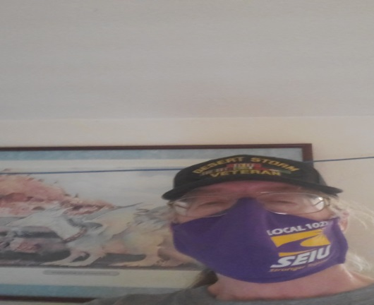

I ask for your vote. I am a 20-year union member and have been a Steward for almost 20 years. I have served on the Executive Board as the Chief Shop Steward and Vice President in the past. As well as, a member of the Bargaining Team for every contract negotiation since 2006. I currently serve on the Housing Assistance Committee. I have served on the Joint Labor Management Benefits Committee, County Safety Committee and Labor Management Committee. I am committed to fight to make things better for our members. I again ask for your vote, so that I may continue to serve.

